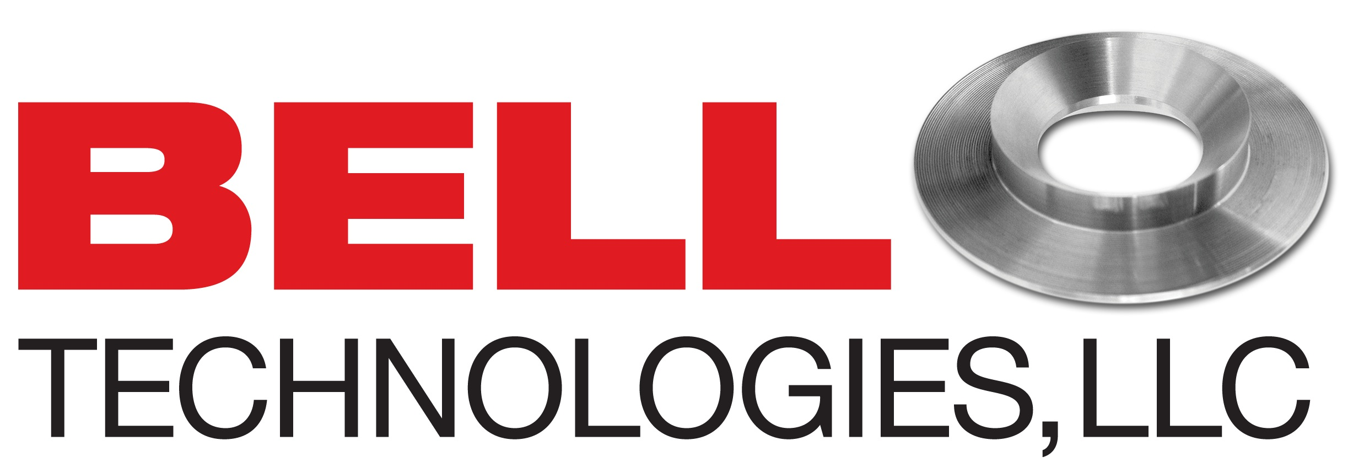

news release

CONTACTS:

Kari Mitchell, Marketing Director

1 (713) 465.7575, kmitchell@belltechnologiesllc.com

Dave Bell, Chief Technology Officer

1 (713) 465.7575, dbell@belltechnologiesllc.com

TORUS CENTER-TAP Orifice Plate Easy Retrofit For Orifice Flange Unions

**Houston, Texas —** Bell Technologies, LLC announces the release of the newest addition to the **TORUS CENTER-TAP product line – The TORUS CENTER-TAP Orifice Plate (TCP OP).** The TCT OP is the sixth addition to the Bell line of meters developed to address flow measurement andoffer an alternative to the high cost of orifice plate and seal ring replacements.

“The **TCT OP** was **c**reated as a replacement device for the standard orifice plate,” said Dave Bell, owner and Chief Technology Officer. “It allows users to easily retrofit their orifice flange unions and offers a simple solution for better measurement, increased longevity, accuracy, repeatability, and a lower cost for installation and maintenance.”

Like its parent product, the **TORUS**, the **TCT OP** is an inexpensive replacement device used to effectively minimize loss and unaccounted for measurement situations or problems. Originally designed for oil and gas, well produced water, steam, chemicals and refined products, this new device works for all sizes, types of process, pressure, flow rates and temperatures.

To learn more about the **TORUS CENTER-TAP Orifice Plate**  and other Bell Technologies products, please contact us at 713-465-7575, [btllcsales@belltechnologiesllc.com](mailto:btllcsales@belltechnologiesllc.com) or go to our website at [www.belltechnologiesllc.com](http://www.belltechnologiesllc.com).

**About Bell Technologies, LLC**

Bell Technologies, LLC, based in Katy, TX, is a company dedicated to development of better process measurement.  Our innovative density, flow, and viscosity measurement solutions provide industry with the tools it needs to better manage a wide range of processes and conditions.

###

**Bell Technologies, LLC, TORUS CENTER-TAP, and the TORUS CENTER-TAP Orifice Plate are trademarks of Bell Technologies, LLC.**   
  
 **For more information (press only) contact:**

Kari Mitchell, Marketing Director

713-465-7575

# For more information on the TORUS CENTER-TAP line of products, go to [www.belltechnologiesllc.com](http://www.belltechnologiesllc.com) or contact Dave Bell at 713-465-7575.